**Library Management System**

**Description:** This is a web-based Library Management System designed to streamline and manage the daily operations of a library. It provides an efficient platform for managing books, categorizing collections, and overseeing member activities. The primary goal of this project is to enhance the functionality of traditional library systems by leveraging modern web technologies to deliver a user-friendly and effective management tool.

**Features:**

* **Book Management:**
  + Efficiently manage and categorize books.
  + Upload book images for better visualization.
  + Implement search functionality to find books by Genre, Author, Publication Date, or Title.
* **Member Management:**
  + Register and manage member profiles.
  + Allow members to borrow books with ease.

### Overview: The Library Management System offers a robust solution for managing the diverse needs of a library. By integrating essential features such as book management, member registration, and lending processes, it simplifies the day-to-day operations for librarians while providing a seamless experience for members. The addition of comprehensive reporting capabilities enhances the system's utility by providing valuable insights into inventory, borrowing trends, and member activities. This project represents a significant step towards digitizing library management and improving the overall efficiency and accessibility of library services.Instructions for New Users on Library Management System

If you are a new user in this management system, this guide is for you.

1. **Create an Account:**
   * Step 1: Fill in the relevant data and click "Register." The page will automatically redirect to the login page.

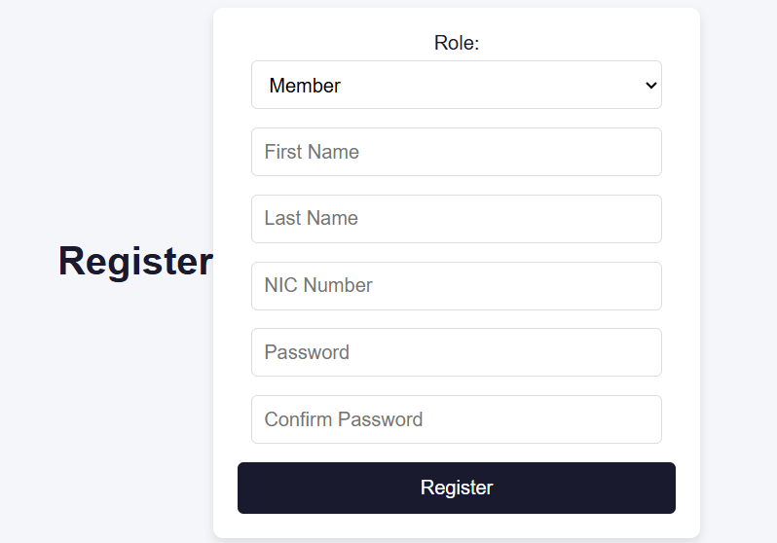

1. **Login:**
   * Step 2: On the login page, enter your NIC number and password. The page will then redirect to the home page where you will see the following UI.

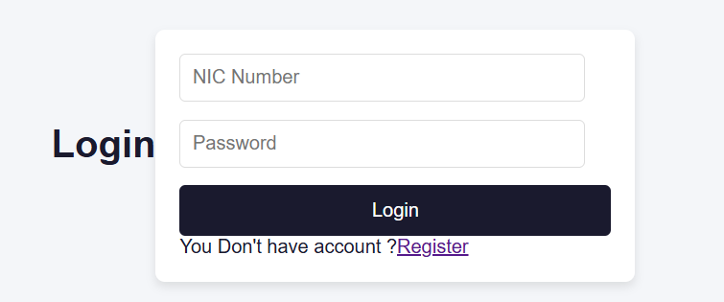

**Searching for Books:**

* You can directly search for any kind of book by its name, author, genre, or publication year.
* To search for a book by author, genre, or publication year, set the parameter in the search bar located at the top left corner and use the main search bar.

**Viewing and Borrowing Books:**

* If you find your book in the collection, you can see the details about the book.
* If you wish to borrow the book, click the request option.
  + If the book is available, you will receive a success message.
  + If the book is not available, you will receive an "Oops" message. Don’t worry, you will also see suggestions for other books.

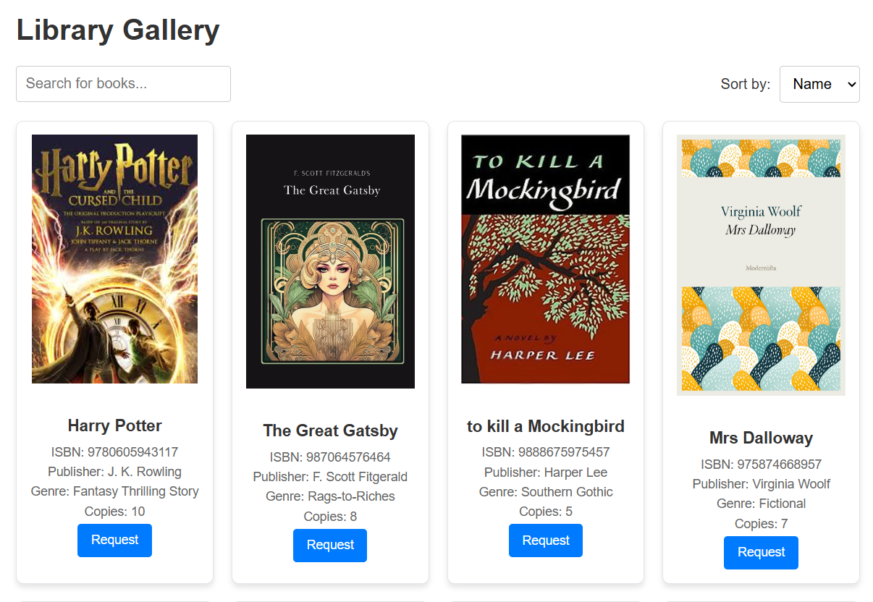

**Borrowing and Returning Books:**

* Feel free to borrow books and make sure to return them within one week. The return process is managed by the librarian.

Thank you for being our member.